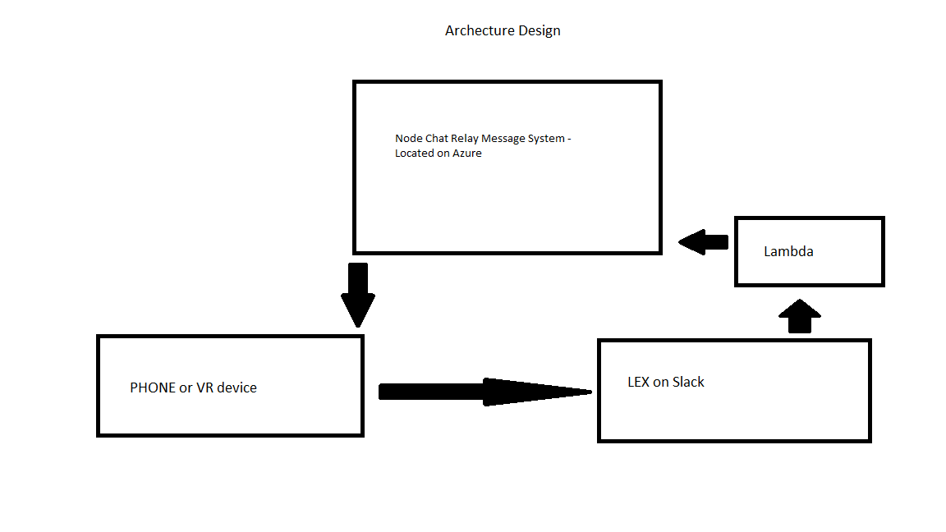

The program workflow

The Phone Application (Unity Android) Logs in as ‘VR’ user to the Chat relay web application (located on Azure) - https://bobcatdino.azurewebsites.net/

The phone app subscribes to the OnMessage Event (used in Socket-IO).

A user logs in the ‘Dinoclubteam’ Slack account and starts a conversation with the ‘newvrbot’ bot

Lex runs the Lambda function which is able to use Socket-IO (Websockets)

The Lambda function logins as in ‘Lex’ to the Chat relay - <https://bobcatdino.azurewebsites.net/>

The Lambda function relays commands from Lex to the Chat Replay

The Phone is listening for messages from ‘Lex’, when it gets a messages it then carries out the command it received.